**AETHER GAME CAFÉ**

**A GOOGLE MARKET RESEARCH**

**Experimental design**

**Introduction**

The design of experiments plays a crucial role in marketing campaigns, allowing managers to test several elements simultaneously, reducing the expense and the time commitment that comes with testing factors individually. Additionally, it even increases the granularity of the response data, giving enterprises a clearer view of what variables are important to their campaign and which way to manipulate the factors to increase customer interaction.

While physical promotional material plays a large part in a company’s visibility, it is uncontested that an online ad, placed in the right location, has the potential of gaining an unrivaled amount visibility than typical media channels. This is particularly true for smaller companies that have less spending power than conglomerates that can air prime time TV ads. Indeed, the power of online advertising is the affordability.

Still, it takes a well-developed ad to garner customer response. A poorly developed ad can mean the ads go unrealized. Luckily, experimental design allows managers to test out which factors will be more impactful for customer recruitment. It is in this purview that we have chosen to develop our project; to run an experiment to determine which combination of attributes will help a specific store attract the most clientele.

**Google Online Marketing Challenge (GOMC)**

The Google Online Marketing Challenge gives students an opportunity to use Google AdWords to create an online marketing campaign. In the past 9 years, over 110,000 students and professors from nearly 100 countries have participated. Over the course of three weeks, students are allotted $250 worth of AdWords credits to develop and run an online advertising campaign for a real business or nonprofit organization. Aside from actual marketing experience solving real-world problems, and the access to using advance marketing industry tools, the teams that develop and communicate the most successful campaigns are awarded appropriately. Students can also choose to participate in the AdWords Certification category; by passing the necessary exams, that student becomes an AdWords Certified Individual in the Google Partners platform.

**Client and Market Analysis**

Aether Game Cafe (AGC), located in Hoboken, New Jersey, is a blend of traditional coffee shop and board games playcenter. Founded by Max Mayer in April 2016, AGC’s unique selling point is the wide variety of games it offers and the ambience it provides for a community get-together.

The café is manned by a staff of 7 employees and focuses on offering customers a unique experience of socializing over an expanse of games and beverages. It attracts gaming enthusiasts and community members alike, and unites the various spheres of the gaming community by hosting several weekly events.

**Our Goal in Experimental Design**

Currently, AGC relies only on ‘Word of Mouth’ for its marketing, indicating a firm foundation to grow its customer base. Because of its stability with little marketing efforts, we attempted to increase their online visibility by generating Google Ads. One obstacle we had to bypass was the declined response rate for newly exposed businesses, as opposed to an already established, well-known business; As a Google Analytics Report points out, it is much more difficult to attract new customers than re-engage past customers. Still, our experimental intends to design a trail by changing the levels of pre-determined factors and identify which factors at which levels will increase the response rate the most.

**Factors & Sample Ads:**

Our first task was identifying which factors in a web ad can potentially impact a customer’s interest. The below picture explains the factors in our Ad. As shown below, there are four components to a Google AdWords ad. The top line of the ad which hyperlinks to the company’s website contains two components – “**Headline 1**” and “**Headline 2**”, separated with a hyphen. The “**Description**” is a two-line statement that summarizes the content of the website, or in AGC’s case, the identity/mission of the store. Our team strategized different messages that would attract a variety of customers, and assigned each version to a factor’s level. Because of the dimension of the campaign, we limited the levels to two per factor and only chose the choices most likely to succeed.

We also considered a second dimension of variability – isolating if **Time of Day** plays a role in response rate can potentially save money if AGC only needs to increase its visibility at certain blocks of the day. We created another factor with levels that indicated ad is posted either on the first half of the day (12:00 AM to 11:59 AM) or the second half (12:00 PM to 11:59 PM).

Lastly, we analyzed that it was important to isolate the variability caused by where the ad was seen. Although the ad would be broadcast to the Hudson County and New York City alike, the response in New York would undoubtedly be higher (New York has a population of 23,900,000 vs. Hudson County’s 2,250,000), despite potentially being less likely to frequent the store. Because AGC was not interested in the source of the attendance, but did want to account for its variability, we chose to use the two locations as a blocking factor.

Below are diagrams of the different elements of the design:



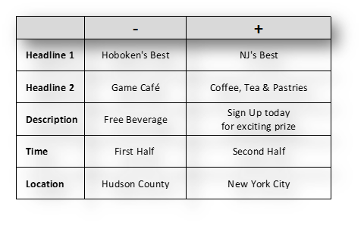

* “Hoboken’s Best Board Games” in Headline 1, “Coffee, Tea & Pastries” in Headline 2 and “Free Beverage” in the Description. The Second Ad has “NJ’s Best” in Headline 1, “Game Cafe” in Headline 2, and “Signup Today for Exciting Prize” in the description.
* Both would be tested in different time and in both the locations.

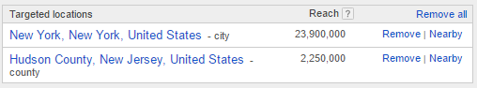

The below pictures show the area covered in each location factors, the left showing Hudson County and the right, New York City. New York’s population exceeds the Hudson County’s by over 100 times.

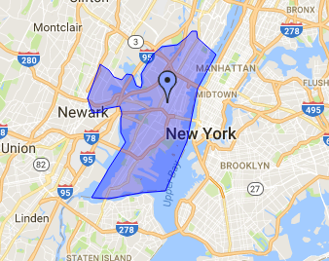 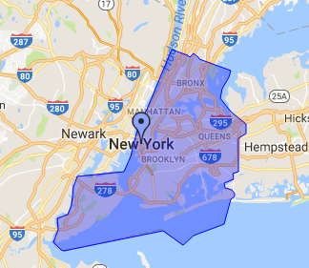

**Fractional Factorial Design**

With the variables identified, we advanced to building an experiment to determine the significance of these factors. The five-factor, two-level experiment would require 25, or 32 runs to develop a trial for each permutation of the factors. While this is plausible for an online advertisement campaign, given the low cost and effort of switching factors, Google’s initiation of the AdWords experiment only began four days prior, and switching often would minimize the value of a full-factorial experiment. An abbreviated number of runs while maintaining a high level of precision would allow better response interpretation. Because of this, we chose to forgo 32 and 16 run experiments and focus on eight permutations over the course of four days.

By forgoing reducing the number of runs to 16 and advancing directly to eight, we ultimately reduced the resolution from a resolution of five to a resolution of three, effectively confounding all two-factor interactions. While this is definitely not desirable, we hypothesized that although there are five factors, one factor, location, is a block and its results (or lack thereof) is not integral to defining a course of action. Despite it confounding a two-way interaction, we felt that the time limitation and general sparsity-of-effects warranted us to view this experiment as if it was a 24 factorial design, reducing our eight-run trial to a resolution of four.

**Setup**

Typically, when designing an experiment, it is standard practice to develop a full factorial design for 2k-p factors and assign the remaining variables to appropriate generators. In a 25-2 experiment, standard order would be applied to three factors, and the remaining two would be applied to the least-confounding variables; in this case, confounding two two-level interactions. The design matrix would like something like this:

 

As we see, D and E are confounding the AB and AC interactions, respectively. The above figure also shows the entire confounding structure. Indeed, we find that the smallest words are three variable interactions, highlighting its resolution. Before running the design, the order would be randomized to eliminate any further bias.

However, when we introduced our design intentions to JMP, we received a completely different outcome. Regardless of the permutations, none of the variables seemed to represent the standard order setup. Additionally, the generators did not take on the values of two two-way interactions, but rather chose a two-way and a three-way interaction, which under normal circumstances would increase confounding.

 

However, we postulated that because the last variable was a block, it was more important for an actual variable to be confounded with a three-way interaction and let the block be further confounded than have both factors confounding two-way interactions.

Another element of JMP’s design that we found interesting is the decision to use the block variable to confound AD/BC, but to do so in a reciprocal manner, where the lower levels of the block were matched with the higher levels of the interactions. In our experiment the outcome of the change was immaterial; the categorical nature of the variable disregards any ordinal value. Still, we assumed that JMP did this similar to how fold-over designs flip the polarities when adding more runs so it reduces the ambiguities of the confounded results.

**Results**

The experiment took place over the course of four days and a total of 65 clicks were counted. JMP calculated the main effects of each of the factors as shown on the contrast diagram and half normal plot below.

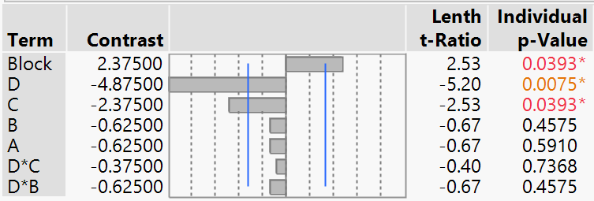 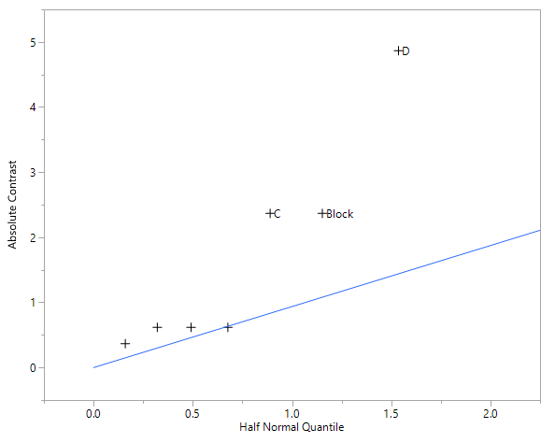

These results show that factors C (Description: “Free Beverage” or “Free Prize”), D (Time of Day: First Half or Second Half) and our blocking variable of location are all significant feature of the total variability. The chart notes that these three factors’ confidence interval do not contain 0 in them, and the orange and red text highlight the fact that their P-value is less than 0.05. We also see their deviation from the norm on a half-normal plot; all three elements digressed far from where they were expected in a normal distribution.

**Pareto Plot**

Another visualization that allows us to gauge significance is the Pareto Plot, a diagram which shows how factors influence the output parameter and to what extent. The Pareto Plot accomplishes two functionalities; first, it gives a clear idea of the major factors in the screening and how switching between the levels by the corresponding units impacts the response variable, and orders them by how impactful they are. This allows us to see, for example, that adding factor D to the positive level, we can increase the response output by nearly 4 clicks over the intercept.

The unique element to the Pareto Plot is the line that measures the cumulative/additive value for the total sum of effect. The concave nature of the line illustrates the Pareto Principle, for which the plot was named. Otherwise known as the Sparsity-of-Effect principle (or the 80/20 rule), this idea underscores the concept that a majority of an experiment’s variability will come from only few of the main factors. The sharp drop after the third factor represents that high drop in impact added by each additional factor, reinforcing those three as the only significant variables.

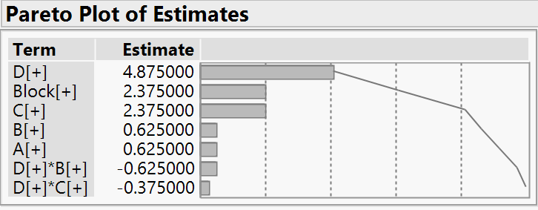

**Model Equation:**

Once we’ve isolated the significant factors, we can now model our function to determine how many clicks our online advertisement will receive by manipulating the levels. We find that the RSquare is at 96%, an impressive correlation.

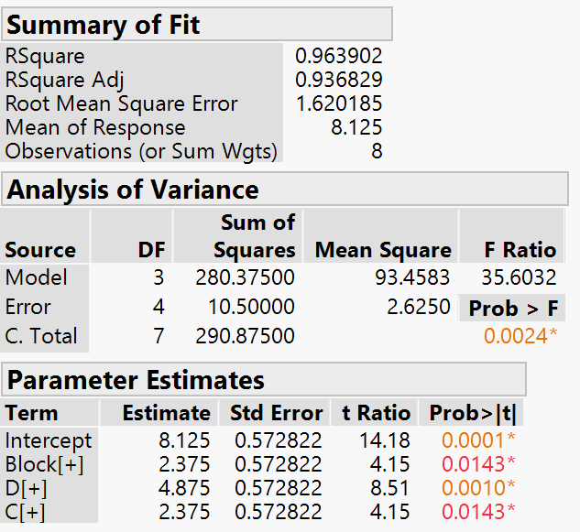

The resulting equation is:

Number of clicks = 8.125 + 2.375*(Location) + 4.875*(Evening) + 2.375*(Description: “Sign up today”)

**Findings - Main Effects Plot:**

The Main Effect Plot explains how the values change when we adjust a level of a single factor. In our case, its contrasts depict our conclusion that the Factors C (Description) and D (Time of Day) have a higher impact, and by proxy a higher significant, in the designing of the final advertisement.

When modeling the description for the final advertisement, the plots clearly show that including the phrase, “A Free Beverage will be provided” (the lower level) reduces the number of responses generated, as opposed to “Sign up today for an exciting prize” (the higher level). The significance of this factor indicates that the variation is rightfully due to the switch in levels, and it would be prudent to assign the second, higher level description to the advertisement. This level produces better branding, evidenced by a higher number of responses, and we should proceed by including “Sign up today for an exciting prize” in the advertisement.

Similarly, the Main Effect Plot shows that the “Time of Day” factor is higher during the afternoon and evening hours. The positive slope from (-) to (+) shows that the advertisement performs sub-optimally when it is shown during the morning hours. A higher number of consumers are likely to respond during the second half of the day, and a more efficient marketing campaign would capitalize on views during the evening and night.

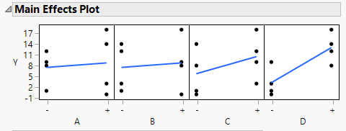

**Findings - Interaction Effects Plot:**

Below, the Interaction Effects Plot illustrates the relationship between any two elements of the 4 factors and one block. The two-level factors allow us to compare these elements in a two-dimensional matrix. This visualization assists in interpreting the significance metrics of interactions on the experiment.

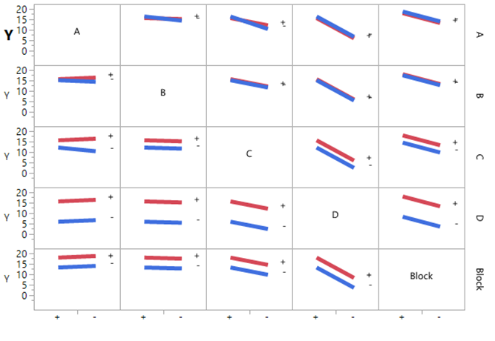

We see from this graph that very few interactions generate dissonance, mostly remaining parallel to reflect their complementary behavior. Although factors A and B seem to intersect with each other, the overlap is minute, and given that both factors are not significant, effect heredity would imply that we would not consider the interaction significant just by looking at them. The same is true about A and C, which has a larger divergence, but still does not meet the significance test.

Therefore, we can determine, even without a significance test, that the interactions of the factors likely have no impact on the variation. This is reinforced once the values of the interactions and their significance are calculated.

**Results – Business Application:**

Our discovery of the significant factors and the levels which increase response rates allow us to generate the advertisement that is likely to promote Aether Game Café’s branding. We have generated two versions of the advertisement that both reflect the significant factors’ higher-response level.

The description is the only content-based factor that we found significant. The first advertisement includes the positive level (“Sign Up today for exciting prizes”) and while the variation in Headline 1 was not considered significant, we decided to place the ad at its second level (“NJ’s Best”).



The second advertisement was generated as a control to re-measure the significance of the first factor (Hoboken’s best) for the duration of the marketing campaign.

To maximize the number of clicks with minimum expenditure, the advertisement can be paused during the first half of the day where the click through rate is lower, and can be reactivated in the second half of the day when the response rate increases significantly.

**Conclusion:**

Through the experiment, we have determined the optimal combination of significant factors to model Aether Game Café Google AdWords campaign to increase brand recognition through click through rate. We have analyzed the factors that can cause variation in an advertisement’s visibility, identified a blocking factor in Location, and determined the respective levels for each factor. By setting up the experiment in a fractional factorial design, we were able to accomplish a valuation in only eight runs, when a 32 run, full factorial design would not practically meet the time limitations. By analyzing the main and interaction effect plots as well as the Pareto plot, we could visualize what we saw in the statistical findings; the description, time of day, and location the ad was placed were factors that the variance can be attributed to, and it is wise to create an ad that reflects this. With the factors’ levels adjusted to represent the highest predicted click through rate, the ad will be run for the remainder of the Google AdWords campaign.